CONTRIBUTIONS TO THE IMPLEMENTATION OF SUSTAINABLE TECHNOLOGIES FOR THE CULTIVATION OF THYME (THYMUS VULGARIS L.) IN THE DOBRODGEA PLATEAU
Liliana PANAITESCU*), Simona NIȚĂ**), M. L. LUNGU*), L. D. NIȚĂ **), I. SHENK*)

*) Ovidius University of Constanta, **) USAMV B Timișoara
Corresponding author: nitasimona70@yahoo.com

Abstract: The pharmaceutical industry has high qualitative and quantitative requirements in terms of ensuring the need for medicinal plants. This is why cultivating medicinal plants in the framework of an integrated technology, with high quality, is an important aspect because the raw material from the spontaneous flora cannot provide for the ever increasing needs. Thyme (Thymus vulgaris L.) is a medicinal and aromatic herb of old tradition, being used in large quantities in the pharmaceutical and spice industries. The dry plant often serves as a raw material for the extraction of active substances, only a part of it is used as a spice, in spice mixtures or in tea manufacturing. The thyme was called the plant of courage, the antiviral effects being known from ancient times. The Greeks and Romans gave the warriors thyme before battles. In the Middle Ages it was used to treat pertussis cough. In today's medicine, thyme is used in creams for muscular and rheumatic pains, and experts appreciate the chance to give up antibiotics in uncomplicated cases. Increased persistent infection, due to the abusive use of antibiotics, is becoming a global issue, an increasingly widespread problem. In agriculture it can be used as a means of plant protection, which inhibits the production of aflatoxins. Volatile oil protects maize grains against Aspergillus flavus mold. (Stahl-Biskup and Saez 2002). Thyme is also an important melliferous plant. Knowing these aspects, the paper presents aspects regarding the climatic conditions in the Dobrogea Plateau area, aspects regarding the requirements of this plant regarding climate and soil, a case study with the "Deutscher Winter" (German Winter) variety, one of the most cultivated. It was found that it was accommodated on cambic chernozem in the experimental area, being resistant to frost. Green herb yields were 12.5 t / ha in crop year 1 and 25 t / ha in year 2.

Key words: sustainable technologies, cultivation, thyme
INTRODUCTION
Thyme is an aromatic and medicinal plant that has returned to the attention of specialists with the expansion of areas cultivated under organic farming. And the farmers in Dobrogea are paying attention to this culture. Thymus prefers the medium and permeable soils in this area, with deeper water groundwater. In the paper, the authors try to meet the demands of farmers, but also of researchers interested in this culture. The experiments were carried out in the climatic and soil conditions near the city of Constanta.
MATERIAL AND METHODS
The variety analyzed and cultivated is "Deutscher Winter". This variety was chosen, because in Dobrogea there are frequent harsh winters with low temperatures and snow freezing, the "Deutscher Winter" variety is one of the few frost-resistant varieties. It is a kind of late inflorescence, which produces large leaves of leaves. It is very vigorous, it branches strongly, forms a big bush and has good regeneration capabilities. At the base, it is strongly drained, with dark green leaves, oval-lanceolate, the color of the inflorescences is light pink.
For the cultivation of thyme, in Europe, almost exclusively varieties, can be used in the "Deutscher Winterthymian" group. By creating new varieties, it is intended to increase the yield of leaves to over 45% and to increase the content in volatile oils to at least 3.5% with a timol content of 40-50%. The varieties cultivated proved to be quite resistant during the years of cultivation, and in the harsher days, with strong and no frosts, losses were found, therefore another goal in creating new varieties is the increase in resistance against frost.
The most cultivated varieties are:
"De Dolj" is a Romanian variety that cares early and produces large quantities of leaves. It is a very vigorous plant with a good regenerative capacity. The content in volatile oil and thymol is medium, medium to large carvacrol.
"Krajovy", is a kind of care, blooms semi-large and produces large amounts of leaves. It is a vigorous plant with a number of leaves to care for the environment. In this variety, the leaves are later, laceolate to egg form. Inflorescences light pink. Syntheses the average amounts of volatile oil and timol and carvacrol.
"Sloneczko", is a Polish kind of care, blooms semi-wild with a large ratio of leaves and flowers, in the detrimetre of the leaves, the quantity of which is medium. The plant is strongly branched with small, dark green, lanceolated leaves. Flowers of this variety are light pink to dark purple, partly pink stripes. Volatile oil content is lower than average, in contrast there are high mean values ​​for timol and carvacrol.
"Varico 1" is a hybrid of Swiss origin that flourishes late and medium to large. It is smaller, less vigorous, gray-green. They are high in volatile oil and medium and timol and carvacrol.
"Varico 2" is also a hybrid of Swiss origin, the successor of the Varico 1 hybrid, which blooms late, but earlier than Varico 1, produces medium to large leaf yields. They are high in volatile oil and timol and carvacrol.
All of these varieties are part of the "Winter German Thyme" variety. Besides the Swiss hybrids describe, new F1 hybrids are being developed in Germany. The yield of leaves and flowers of these varieties ranges from 57% (low to medium) to 66% (high-very high), leaf yield from 3 tonnes / ha (medium to medium) at 4.4 tonnes / ha (high), volatile oil content from 1.5 ml / 100 g (medium to medium) to 4 mg / 100 g (high), timol from 57% (low mean) to 67% (high) and carvacrol from 4, 2% to 4.6% (medium-high).
RESULTS AND DISCUSSIONS
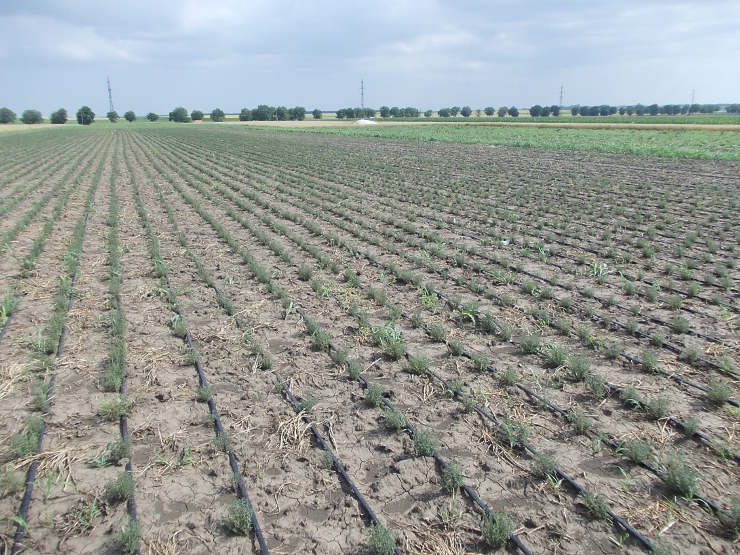
Fig. 1 - The tymus culture in Dobrogea
Choosing the technology variant
Cultivation of the thyme is usually carried out by direct sowing in the field. With very small seeds, the land must be prepared very well and in the case of lands that tend to pond or heavily floured, a seed culture establishment is safer. Therefore, in our experiment, we have opted for obtaining more seedlings first, then cultivating them in the field.
For the sowing of the field thimble, the ground was very well cut, leveled and rolled up to ensure a uniform rise and a better crop. The creation and processing with the combiner in the autumn created the premises of a good work in the spring. In the spring, the ground was prepared by repeated work with the germinating bed combiner, aggregated with the vibrator and rollers.
Sowing cane in the field can be done from two weeks from March to mid May at the latest. Thymus requires the ground to be ground and leveled (0.3 - 0.5 cm deep).

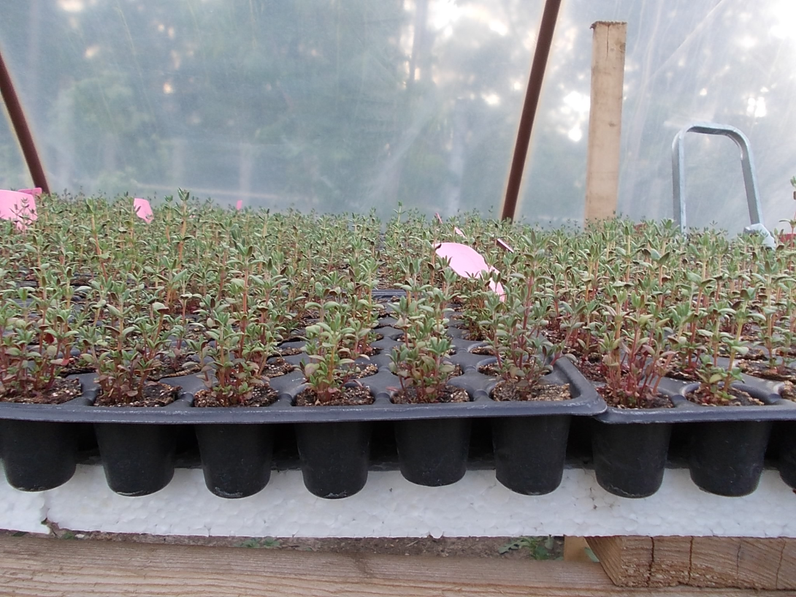
Fig. 2 – The cultivation of thymus in alveolus - detail
Growing seedlings followed by their planting in the field ensures a dense, vigorous and uniform crop, but is more expensive than sowing in the field. Seedlings of 3 to 5 yarns were grown in alveoli. For the production of seedlings, 5-7 seeds were introduced into each cell, then the work was done. The specimens were coated with a thinner layer of substrate to avoid rapid dehydration. Until germination, optimum temperatures of 20-25 ° C were maintained, after seed germination, temperatures were lowered to 16-18 ° C during the day and 12-14 ° C at night. In sunny weather, intense sunlight, the shades were shaded. To pass the quenching phase, before the planting, the plants were subjected to a frost-free period, but with a lot of sunshine, for 7-14 days. When plums reached 5-7cm high they were planted in the field (end of May)
The precultivated seedling seedlings have been planted in the field at a distance of 25-30 cm between the rows and 15-20 cm between the plants per row, on average requiring a number of 80000 plants per hectare. Mechanized planting with seedlings is possible. After planting the seedlings, if it does not rain [13], in Dobrogea it is necessary to intervene with irrigation water to ensure uniformity of growth and to avoid any goals in a row.
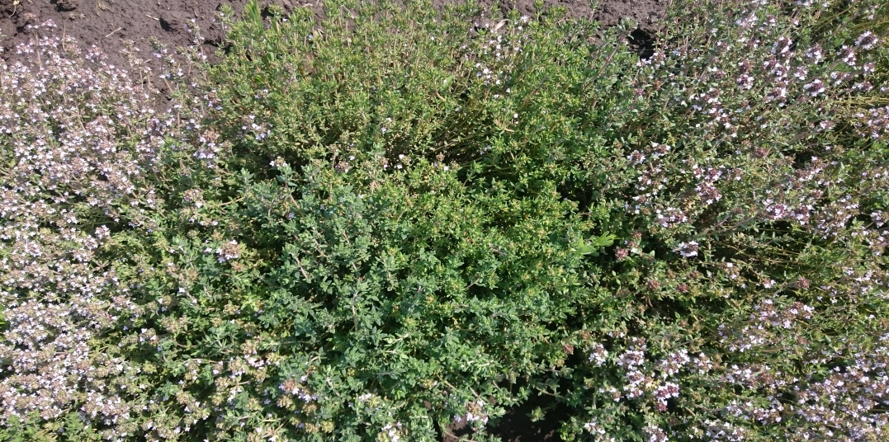
Fig. 3 – Thyme bush
Care work. In the first stages after planting the seedlings, in order to avoid the risk of frost, the crop was covered with a hortiagryl net, which ensures a uniform moisture and avoiding crust formation after large precipitations. Repeated bakeries (4) were performed on all vegetative periods. During the vegetation several periodic field checks were carried out.
Irrigation of the seed after the sowing is not recommended because it is possible to inhibit the emergence of very small seeds of thyme. In crops established by seedling planting, growth can be inhibited by long drought periods, and it is recommended to irrigate the crop through aspersia, especially in the early stages of vegetation. It is also beneficial to irrigate after cutting the thyme, to stimulate its regeneration and rapid growth.
An important care work is the elimination of infested plants or those attacked by pests, a very expensive work [5].. Ecological cultivation of the greenberry becomes more cost-effective than the conventional method due to market development.
Diseases and Pests. In field-field cultivation, pest and pest infestation remained within limits. Erysiphe, Botrytis, aphids and nematodes attacked. More rarely, the thyme was also affected by Erysiphe biocellata Ehr. and various pathogens causing the staining of leaves, as well as infestations with Alternaria alternata (Fr.) Keissl., Puccinia menthae Pers., Aecidium thymi (Fuckel).
Of the pests, aphids were reported, especially Myzus ornatus Laing. and the caterpillar of Zyngaena trifolii Esp. In May, June and August, the caterpillars of Acidalia ornata Purp were reported. and A. Rubiginata Hufn. The brownish-gray colored handle, A. incanata L., in two generations, in May and July.
The seedling material (Cuscuta epithymum L. Subsp. Epithymum) can be spread through the seed material [1]. The affected plants were mown, then the exposed soil was treated with a solution of 15-20% iron sulphate II to remove the parasite completely. Outside of the torch no damage was observed due to the parasites. A cicada under the name Eupteric decemnotata (Rey 1993) can create small damage on hot summer days.
Harvest and production. Herba thymi was harvested before the flower until the latest when the first blossoms began to open. In the first year, only one crop was obtained. The harvest is not done later than early September because shoots make it to the maturity necessary to go through the winter without problems. In the second year, two cuts were made, the first in May / June and two after the regeneration of the shoots in September. The harvest was done in dry, warm and sunny weather. The quantities harvested are shown in Table 1.
Table 1
The quantities harvested of thymus
Harvest  (tonnes per hectare) | Poor harvest | High harvest
Green harvest  Year 1 | 9,7 | 14,5
Green harvest  Year 2  Harvest 1 | 19,4 | 29,1
Green harvest  Year 2  Harvest 2 | 10,7 | 1,16
Dry harvest  Year 1 | 2,0 | 3,0
Dry harvest  Year 2  Harvest 1 | 4,0 | 6,0
Dry harvest  Year 2  Harvest 2 | 2,2 | 2,4

CONCLUSIONS
The thyme is a plant that finds good development conditions in Dobrudja;
The variety analyzed and cultivated is "Deutscher Winter", able to withstand the harsh winters in Dobrogea;
Establishing seedlings is safer;
For the sowing of thyme in the field, the ground must be very well chopped, leveled and rolled up, to ensure uniform growth and a good crop;
The precultivated seedling seedlings can be planted in the field at a distance of 25-30 cm between the rows and 15-20 cm between plants per row, on average requiring a number of 80000 plants per hectare;
After planting the seedlings, in Dobrudja it is necessary to intervene with irrigation water to ensure uniformity of growth and to avoid any gaps in turn;
In the first stages after planting the seedlings, in order to avoid the risk of frost, the crop must be covered with a hortiagryl mesh, which ensures uniform humidity and avoiding crust formation after large precipitations;
It is necessary to carry out the repeated bite (4), all vegetative period;
Several regular field checks are required during vegetation;
It is necessary to eliminate the infested plants or those attacked by the pests.

BIBLIOGRAPHY
Axinte M., Borcean I., Roman Gh. V. Muntean L. S., 2006, Fitotehnie. Editura Ion Ionescu de la Brad, Iaşi.
Bâlteanu Gh., Bârnaure V., 1979, Fitotehnie. Editura “Ceres”, Bucureşti.
Bâlteanu Gh., Bârnaure V., 1989, Fitotehnie. vol. I, Editura “Ceres”, Bucureşti, .
Bâlteanu Gh., Salontai Al., Vasilică C., Bârnaure V., Borcean I., 1991, Fitotehnie. Editura “Didactică şi Pedagogică”, Bucureşti.
Bâlteanu Gh., 2001, Fitotehnie. vol. 2, Editura “Ceres”, Bucureşti.
Blaga Gh., Rusu I., Udrescu S., Vasile D., 1996, Pedologie. “Editura Didactică şi Pedagogică”, RA, Bucureşti.
Burzo I., Aurelia Dobrescu, Viorica Voican, Elena Delian, 1996, Curs de Fiziologia Plantelor. Atelierul de multiplicat cursuri al Universităţii de Ştiinţe Agronomice şi Medicină Veterinară, Bucureşti.
Hera C., Borlan Z., 1980, Ghid pentru alcătuirea planurilor de fertilizare. Editura “Ceres”, Bucureşti.
Muntean L.S., Borcean I., Axinte M., Roman Gh. V., 1995, Fitotehnie. Editura “Didactică şi Pedagogică”, Bucureşti.
Muntean L.S., Borcean I., Roman Gh. V., Axinte M., 2003, Fitotehnie. “Editura Ion Ionescu de la Brad”, Iaşi.
Oancea I., 2003, Tehnologii Agricole Performante. Ed Ceres.
Pintilie C., Sin Gh., 1974, Rotaţia culturilor de câmp. Editura “Ceres”, Bucureşti.

E.Stahl-BiskupR.P.Venskutonis, 2014, Handbook of Herbs and Spices (Second edition), Volume 1, Woodhead Publishing Series in Food Science, Technology and Nutrition, Thyme, Pages 499-525
Zamfirescu N., 1977, Bazele biologice ale producţiei vegetale. Editura Ceres, Bucureşti.

